Task 1: CSS Basics

CSS: Cascading Style Sheets
CSS (Cascading Style Sheets) is a programming language used to style HTML elements. It controls the appearance of a web page, including fonts, colors, layouts, and more. By separating the content (HTML) from the presentation (CSS), it makes web design more efficient, maintainable, and reusable.

Role of CSS in Web Development
- Styling: CSS defines the visual appearance of web pages, making them visually appealing and user-friendly.
- Separation of Concerns: It separates the content (HTML) from the presentation (CSS), improving code organization and maintainability.
- Responsiveness: CSS can be used to create responsive designs that adapt to different screen sizes and devices.
- Accessibility: CSS can be used to improve the accessibility of web pages for people with disabilities.

Creating a Simple HTML Document with CSS
HTML Document (index.html):
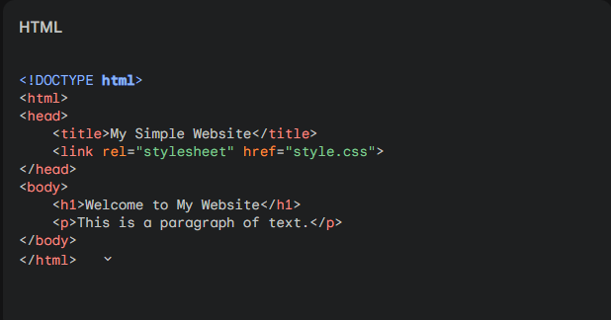
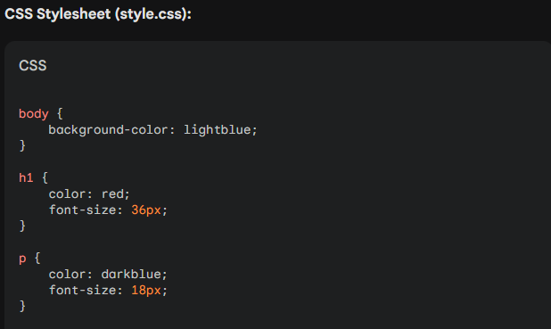

Explanation of CSS Code
- body selector: Targets the <body> element of the HTML document.
  - background-color: lightblue;: Sets the background color of the entire page to light blue.
- h1 selector: Targets all <h1> elements on the page.
  - color: red;: Sets the color of the <h1> text to red.
  - font-size: 36px;: Sets the font size of the <h1> text to 36 pixels.
- p selector: Targets all <p> elements on the page.
  - color: darkblue;: Sets the color of the <p> text to dark blue.
  - font-size: 18px;: Sets the font size of the <p> text to 18 pixels.
By combining these HTML and CSS files, you create a simple web page with a light blue background, red header text, and dark blue paragraph text. You can customize the styles further by adding more CSS rules and selectors.

